Project Design Phase-II
Technology Stack (Architecture & Stack)

Technical Architecture:
The Deliverable shall include the architectural diagram as below and the information as per the table1 & table 2

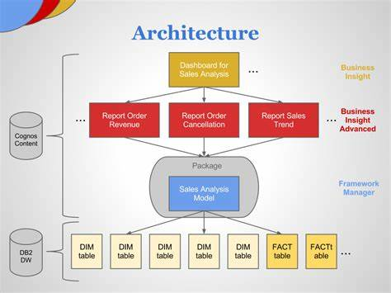

Components & Technologies:

S.No | Component | Description | Technology
1 | User Interface | How the user feels comfortable with the | IBM Cognos Analytics with Watson
 |  | interface (ie) UI/UX design.
2 | UPLOAD DATA | Logical explanation of the process in the appilacation | IBM Cognos Analytics with Watson
3 | PREPARE DATA | Logical explanation of the process in the appilacation | IBM Cognos Analytics with Watson
4 | EXPLORATION | Logical explanation of the process in the appilacation | IBM Cognos Analytics with Watson
5 | PRESENT DATA | Logical explanation of the process in the appilacation | IBM Cognos Analytics with Watson
6 | Cloud Database | Clouds database sevices | IBM DB2, IBM Cloudant
7 | File Storage | The requirement to store files | IBM CLOUD
8 | Infrastructure (Server / Cloud) | Deployment of Applications on Local or Cloud Systems | IBM CLOUD.

Application Characteristics:

 | S.No | Characteristics | Description | Technology
 | 1. | Open-Source Frameworks | Utilised in the application's framework | IBM COGNOS With Watson,IBM
 |  |  |  | CLOUD
 | 2. | Security Implementations | Use of firewalls and other security measures throughout. | LDAP OR Active Directory
 | 3. | Scalable Architecture | Design of the application | Three server tiers: Web Tier.
 | 4. | Availability | Application accessibility on all platforms without user inconsistency, as well as continuous availability monitoring. | WebSphere® Application Server,
 |  |  |  | Cognos® Business
 |  |  |  | Intelligence server
 | 5. | Performance | Check the application's effectiveness and performance. | 3IBM® Cognos® Performance
 |  |  |  | Management Hub (PMHub)
Is the system robust?
 | Yes, the data analysis software that is being built is reliable.
Is it highly modifiable?
 | Yes, the system is user-friendly and open to developers' modifications and improvements.
Is it scalable?
 | Yes, the system is adaptable and can be expanded as needed.
Is it buildable?
 | It is possible to develop on a tight budget, indeed.

